OMB No. 0925-0001 and 0925-0002 (Rev. 10/15 Approved Through 10/31/2018)

BIOGRAPHICAL SKETCH

Provide the following information for the Senior/key personnel and other significant contributors.  
Follow this format for each person. **DO NOT EXCEED FIVE PAGES.**

NAME: Sarah Elizabeth Emerson

eRA COMMONS USER NAME (credential, e.g., agency login):

POSITION TITLE: Graduate Student

EDUCATION/TRAINING (Begin with baccalaureate or other initial professional education, such as nursing, include postdoctoral training and residency training if applicable. Add/delete rows as necessary.)

| INSTITUTION AND LOCATION | DEGREE  (if applicable) | Completion Date  MM/YYYY | FIELD OF STUDY |
| --- | --- | --- | --- |
| University of Bath, U.K | BSc Hons | 05/2011 | Biology |
| University of Vermont, Burlington, VT. U.S.A. | PhD | Predicted 2019 | Biology |

# A. Personal Statement

I am a current second year graduate student at the University of Vermont, I have been working towards my PhD in Dr. Alicia Ebert’s lab in the Department of Biology since 2014. I am from England, and did my undergraduate research at the University of Bath, UK. In my third year I did a study abroad program at the university of Colorado, Boulder under Dr. Jerry Stitzel. In this year I worked full time as a research assistant and learnt fundamental lab techniques. My year abroad enhanced my degree to a BSc with professional placement. At my current position in the Ebert lab we use zebrafish as a model organism to study eye development. My project specifically looks at the downstream signaling events of two well-known guidance cues, Semaphorins and Plexins and how they control early eye development in a non-canonical fashion. In my time at UVM I have become proficient in key developmental biology techniques at genomic, protein and whole organismal levels. Key techniques include *in situ* hybridization and the generation of antisense riboprobes, PCR, generation of full length RNA, Morpholino and CRISPR gRNA design and microinjections into zebrafish embryos, zebrafish husbandry, cell culture, western blotting, embedding, sectioning and staining of zebrafish embryos and immunohistochemistry. I have been fully trained and am proficient in fluorescent confocal microscopy and the use of analytical software. I am a keen research scientist, and am always excited to learn new techniques and this is possible in conjunction with other labs at UVM. Our lab has much collaboration, especially with Dr. Bryan Ballif of the Biology department, Dr. Paula Demming and Dr. Seth Frietze of UVM department of medical lab and radiation sciences, all of which support my progress and are very active in progressing my research and development in terms of providing guidance and resources in their areas of expertise. Preliminary data so far has enabled me to compile a paper as primary author for submission to Developmental dynamics, patterns and phenotypes. Career goals include completion of PhD by 2019/2020, followed by a postdoctoral position in Developmental Biology and hopefully a research position with a strong emphasis on teaching at the college level in the same field thereafter. Current funding is from Dr. Ebert and Dr. Ballif’s joint NSF grant 1456846. I have been able to present my data many times throughout my 2 years as a graduate student, I am a current member of the Society for Developmental Biology and have been fortunate to attend and present posters of my data at regional and national meetings over the last 2 years.

*Posters*

* Identification of target genes downstream of PlexinA2 /Semaphorin 6a signaling in zebrafish. **Emerson. SE,** Ebert. AM, Northeast Society for Developmental Biology. Woods Hole, MA, April 10-12, 2015.
* Identification of target genes downstream of PlexinA2 /Semaphorin 6a signaling in zebrafish. **Emerson. SE,** Ebert. AM, UVM Student Research Conference, April 23, 2015.
* Identification of target genes downstream of PlexinA2 /Semaphorin 6a signaling in zebrafish. **Emerson. SE,** Ebert. AM, Dartmouth Neuroscience Day, May 8, 2015.
* Identification of genes downstream of PlexinA2 and Semaphorin 6a involved in proliferation and migration during early eye development. **Emerson. SE,** Ebert. AM, Society for Developmental Biology. Snowbird, UT, July 9-13 2015.
* The role of the Plexin A family in eye development. **Emerson. SE**, Light, S.E., St. Clair, R.M., Ballif, B.A. and Ebert, A.M.NBH Forum. UVM, Jan 23, 2016.
* Identification of target genes downstream of PlexinA2 /Semaphorin6a signaling in zebrafish. **Emerson. SE**, Light, S.E., St. Clair, R.M., Ballif, B.A. and Ebert, A.M.Northeast Society for Developmental Biology. Woods Hole, MA, April 10-12, 2016.

*Presentations*

* UVM Graduate seminar. “Identification of genes downstream of PlexinA2 and Semaphorin 6a involved in proliferation and migration during early eye development” April 3rd 2015
* UVM Graduate seminar. “The role of the Plexin A family in eye development” March 18th 2016
* Student research conference UVM. *“*Identification of target genes downstream of Semaphorin6A/PlexinA2 signaling in zebrafish." April 26th 2016

Out reach so far has included helping at Milton Middle School, VT Science Fair on Feb 15, 2015 as a Judge. Guest TA for a senior Developmental Biology lab at St. Michaels College, VT, where we provided zebrafish embryos and guided independent student research designs. Dec 1, 2015. In the future I plan to continue to participate in outreach events and guest lecture for the Developmental Neurobiology class at UVM. I am a very dedicated student and in getting this fellowship I will be able to continue my research at UVM and progress towards my goal of being an independent developmental biologist.

# B. Positions and Honors

| ACTIVITY/  OCCUPATION | START DATE MM/YYYY | END DATE MM/YYYY | FIELD | INSTITUTION/  COMPANY | SUPERVISOR/ EMPLOYER |
| --- | --- | --- | --- | --- | --- |
| Predoc | 08/2014 | Present | Biology | University of Vermont | Dr. Alicia Ebert |
|  |  |  |  |  |  |
|  |  |  |  |  |  |

**Teaching experience**

*Teaching Assistant*

BCOR 11- Exploring Biology Lab UVM, Fall 2014

BCOR 101- Genetics recitation UVM, Spring 2015

BCOR 21- Exploring Biology Lab for AP Bio students UVM, Fall 2015

BCOR 103- Cell Biology UVM, Spring 2016

BCOR 21- Exploring Biology Lab for AP Bio students UVM, Fall 2016

**Awards** May 2016- Department of Biology Graduate teaching assistant of the year award.

# C. Contribution to Science

**1) Professional Research Assistant** July 2009 – Aug 2010

*Institute of Behavioral Genetics-University of Colorado*

As a part of my degree, I worked with Dr. Jerry Stitzel on a year -long project into a behavioral and cell based assessment of α5 nicotinic acetylcholine receptor subunits. This was an incredibly rewarding year abroad, learning many molecular and cell culture techniques, such as transformations, transfections, DNA digests, purifications, gel electrophoresis, PCR, RT-PCR, phenol extraction RNA analysis, and SDS-PAGE. I also became proficient at cell culture, counting, splitting and feeding cells. I conducted several behavioral experiments using mice, and refined existing behavioral protocols to maximize results. I am comfortable with giving injections and handling. As an aside I learnt how to use fluorescence microscopy to generate images of labeled cells.

**2) Dissertation Student** Jan 2011 – May 2011

*Department of Biology and Biochemistry- University of Bath*

Title: Comparison of Azetidine Compounds.

I worked with Professor Sue Wonnacott to analyze any binding activity and the functionality of sazetidine and 5 novel azetidine containing compounds at nAChRs. Firstly using isolated rat brain membranes in competitive binding experiments using [3H] epibatidine to determine any receptor binding. Secondly to determine agonistic or antagonistic functionality of the drug on nAChRs in calcium release assays. My results were shown at a British Pharmacological Society meeting in December 2012 thanks to a current PhD student in Bath who continued the study. This study consolidated my practical lab skills, and increased my confidence in individual work.

**3) Publications written.**

I have generated data and completed a manuscript for publication, to Developmental Dynamics, patterns and phenotypes, which will be submitted by 06/2016.

**“**Identification of target genes downstream of Semaphorin6A/PlexinA2 signaling in zebrafish”

**Sarah E. Emerson1**, Riley St. Clair1, Ashley Waldron1, Sierra Bruno1, Anna Duong1, Heather Driscoll2, Bryan Ballif1, Sarah McFarlane3, Alicia Ebert1

1.Department of Biology, University of Vermont, Burlington, VT 05405 USA, 2. Vermont Genetics Network, University of Vermont, Burlington, VT 05405 USA, 3. Department of Cell Biology and Anatomy, Hotchkiss Brain Institute, University of Calgary, Calgary, Alberta T2N 4N1, Canada

*Keywords. Retina, eye development, rasl11b, microarray, proliferation, rx3:GFP.*

**Background**: Plexins (Plxns) and Semaphorins (Semas) are a family of signaling factors that were initially discovered to act as repulsive signals for migrating neurons by influencing actin dynamics growth cones (Kolodkin et al., 1992; Luo et al., 1993; Rosslenbroich et al., 2005). It is becoming widely appreciated that the Plxn/Sema family have a much broader role in development than just axon guidance. Given that these signaling molecules have such varied roles in development it is important to understand downstream events. This project focuses firstly on the effects of a single Sema/Plxn interaction, Sema6A and PlxnA2, which we have found to be expressed in the eye fields as early as 4-8 somites (10 hpf, hours post fertilization) (Ebert et al., 2014). We propose an additional novel early role for Sema6A and PlxnA2 in proliferation of RPCs in early eye vesicles. **Results**: MO knockdowns of Sema6A or PlxnA2 share phenotypes of reduced proliferation and migration defects in the early developing eye. Microarray analysis of RNA isolated from 18 hpf morphant embryos have uncovered a set of genes that are differentially regulated in common to both Sema6a and PlxnA2 morphants compared to controls. 57/58 genes in common were found to be significantly up regulated in morphants. *In situ* hybridization validation has confirmed differential expression of select genes, and further characterization of one differentially regulated gene, *rasl11b,* has uncovered its role in regulating proliferation in the developing zebrafish eye. **Conclusions**: This study has uncovered a novel early role for PlxnA2/Sema6A signaling in maintaining appropriate proliferation of optic vesicles during early eye development. Microarray analysis has generated a resource of gene targets downstream of Sema6a/PlxnA2 signaling, which can be further investigated to elucidate the downstream effects of this well known signaling pathway.

Ebert, A.M., Childs, S.J., Hehr, C.L., Cechmanek, P.B., McFarlane, S., 2014. Sema6a and Plxna2 mediate spatially regulated repulsion within the developing eye to promote eye vesicle cohesion. Development 141, 2473-2482.

Luo, Y., Raible, D., Raper, J.A., 1993. Collapsin: A protein in brain that induces the collapse and paralysis of neuronal growth cones. Cell 75, 217-227.

**4) Presentations**

I have presented my data in the form of posters at meeting across the U.S, at regional and national conferences for the Society of Developmental Biology, at University research conferences at UVM and Dartmouth University. And have given oral presentations at UVM neuroscience day and for Departmental graduate student seminars. Poster abstract sample: NESDB 2016 Abstract

‘Identification of genes downstream of PlexinA2 and Semaphorin 6a involved in proliferation and migration during early eye development.’

**Emerson, S.E.1**, Light, S.E.1, St. Clair, R.M.1,2, Ballif, B.A.1,2 and Ebert, A.M.1,2 *1*

*Department of Biology, 2Neuroscience Graduate Program, University of Vermont, Burlington VT 05405, USA*

During development, migrating neurons navigate to their correct synaptic targets by using a variety of transmembrane and secreted guidance cues in their environment. Plexins and Semaphorins are a family of signaling factors, initially discovered to act as repulsive signals to migrating neurons by influencing actin dynamics at the growth cone. It is becoming widely appreciated that the Plexin/Semaphorin family has a much wider role in development than simply axon guidance. Using a combination of Morpholino knockdowns*, in situ* hybridization and immunohistochemistry in zebrafish, we have uncovered a novel early role for PlexinA2 in maintaining proper cohesion and proliferation in migrating optic vesicles. Using microarray analysis we have determined a set of downstream genes that are differentially regulated by PlexinA2 and Semaphorin6A signaling. Further characterization of one of these genes, *rasl11b*, has uncovered its role in maintaining proliferation in the early developing eye.

# D. Research Support

*Scholastic Performance*

**Undergraduate Results 2007-2011. University of Bath. United Kingdom. (See grading system below)**

BSc Honors Biology With Professional Placement.

**First year degree Classes: 2007/2008**

Biodiversity, 71% A

Skills and techniques, 61% B

Cell biology, 75% A

Ecology and evolution, 75% A

Biochemistry, 69% B+

Human and animal physiology, 78% A

Skills and techniques 2, 78% A

Cell and molecular biology, 76% A

Genetics, 62% B

The biosphere. 60% B

**Second year Classes: 2008/2009**

DNA (making breaking and disease), 69% B+

Insect biology, 71% A

Concepts in evolution, 74% A

Practice of science, 72% A

Molecular genetics of vertebrate development, 71% A

Infection and immunity, 69% B+

Cellular neurobiology, 65% B

Bacteriology, 69% B+

Virology, 64% B

Data interpretation. 71% A

**Third year (Year long Professional Placement)** 2009/2010

Institute of Behavioral Genetics, University of Colorado, CO, USA. Pass with Distinction.

**Fourth year Classes: 2010/2011**

Sexual conflict, 73% A

Biology as a worldview, 73% A

Biological ethics, 69% B+

Genomes, 74% A

Vertebrate development, 65% B

Conservation Biology, 65% B

Evolution in deep time, 67% B+

Systems and developmental neurobiology, 66% B

Dissertation lab project. 67% B+

Overall grade received = 68.98 = 2:1 Upper second-class degree. (Grade B+).

(In the U.K you need a 70 for the highest possible grade, a 1st class degree = A. The lowest passable grade is a 40, a third class degree, which is grade D.)

**2014-Present. Graduate Results The University of Vermont, Burlington, VT.**

|  |  |  |
| --- | --- | --- |
| 2014 | Graduate seminar | A |
| 2014 | Techniques in microscopy | A |
| 2014 | Introduction to Pharmacology | A |
| 2015 | Bio lunch | A |
| 2015 | Cell Biology | A- |
| 2015 | Biochemistry of human disease | A+ |
| 2015 | Developmental Mol. Genetics | A |
| 2015 | Graduate Seminar | A |
| 2016 | Neurodevelopment | A+ |
| 2016 | Sensory Systems and hormones | A |
| 2016 | Graduate seminar | A |
| 2016 | Proposal Writing | A |
| 2016 | Senior Project | A |

Transcript totals as of May 2016. GPA 3.95

**________________________________________________________________________________**

**Objective and significance**

During development, migrating neurons navigate to their correct synaptic targets by using a variety of transmembrane and secreted guidance cues in their environment. Plexins (Plxns) and Semaphorins (Semas) are a family of signaling factors that were initially discovered to act as repulsive signals for migrating neurons by influencing actin dynamics at growth cones (Kolodkin et al., 1992; Luo et al., 1993; Rosslenbroich et al., 2005). It is becoming widely appreciated that the Plxn/Sema family have a much broader role in development than just axon guidance, and have been implicated in vasculogenesis (Serini et al., 2003), tumorigenesis (Neufeld and Kessler, 2008), immunity (Shi et al., 2000) and bone development (Behar et al., 1996). Given that these signaling molecules have such varied roles in development it is important to understand how they work. This project focuses firstly on the effects of a single Sema/Plxn interaction, Sema6A and PlxnA2, which we have found to be expressed in the eye fields as early as 4-8 somites (10 hpf, hours post fertilization). We propose an additional novel early role for Sema6a and PlxnA2 in controlling migration and proliferation in early eye vesicles. The downstream signaling mechanisms and target genes that are controlled by Semas and Plxns are largely unknown. To address this in early eye development, we aim to identify, validate and characterize downstream target genes of Sema6A and PlxnA2 at 18 somites (18 hpf), using a combination of Morpholino knockdowns (MO), microarray analysis*, in situ* hybridization and immunohistochemistry in zebrafish. In preliminary work for aim 1, we have begun to decipher the down stream targets of the Sema6A/PlxnA2 signaling pathway. Using microarray analysis, we have generated a data set of downstream genes that are differentially regulated when PlxnA2 and Sema6A signaling is impaired. Many of these genes are involved in cellular proliferation, cell cycle regulation and migration. Strikingly, out of 58 genes that were differentially regulated in both Sema6A and PlxnA2 MO groups, 57 were up regulated and only one down regulated. This result suggests that this signaling pathway is highly repressive, and through looking at differences in chromatin structure and histone modifications between wild type and mutant zebrafish retinal precursor cells (RPCs) for aim 2, we will investigate how this repression is generated. Multiple members of the Plxn family can bind and be activated by the same Sema ligands. In other preliminary work*,* we have shown that PlxnA1 has a compensatory role for PlxnA2 in the early eye. There are 4 members of the PlxnA family, PlxnA1-4. Aim 3 will expand on knowledge of PlxnA1 and A2 and look at the expression patterns and roles of the remaining Plxn A family members to begin understanding their roles in early eye development. Further experiments will address if there is compensation between other family members, and to further investigate downstream regulation imparted by the Sema6A/PlxnA signaling pathway. This body of work will not only uncover how Semas and Plxns signal in early eye development, but potentially in the many other aspects of development that they are involved in.

* **Aim 1**- Using functional developmental methods to elucidate roles of genes identified downstream of Sema6A/PlexinA2 signaling in early eye development.
* **Aim 2 –** Delineate the downstream transcriptional effectors of Sema6A/PlxnA2 signaling in retinal precursor cells during early eye development.
* **Aim 3 –** Characterizing expression and function of additional Plexin A family of receptors in early zebrafish eye development.

**Literature review**

*Eye development.*

The eye field is first established in the developing nervous system at the anterior neural plate, prior to neural tube closure. Several evolutionarily conserved eye field transcription factors (EFTFs) drive eye specific cellular fates, and include *Pax6*, *Six3, Lhx2, Rx* and *Otx2*. These transcription factors are expressed at late gastrula stages, and mis-expression results in improper eye formation (Zuber et al., 2003). *Pax6* as a master regulatory gene for eye development and overexpression can result in ectopic eyes (Halder et al., 1995). The EFTFs have overlapping expression domains in the presumptive eye field and sequentially turn on to further specify more specific regions using feed back inhibition loops. Following the closure of the neural tube, the eye fields evaginate from the lateral diencephalon, forming two optic vesicles. Sonic hedgehog (*shh*) is expressed in the anterior midline of developing embryos and drives *pax2* expression, which in turn inhibits *pax6* expression. *Shh* expression is essential for turning off eye cell fates along the midline to allow for correct separation of the optic vesicles (Macdonald et al., 1995). Overexpression of *PAX6* along the midline, or a loss in *SHH* can result in holoprosencephaly in humans (Roessler et al., 1996). Once the optic vesicles have correctly separated and migrated bilaterally, they make contact with surface ectoderm of the head. This drives proliferation of the surface ectoderm, leading to development of the lens placode. The lens placode continues to proliferate and invaginates to form a separate vesicle of lens tissue. This invagination is synchronous to the invagination of the optic vesicles, by which point has developed polarity. The inner surface of the optic vesicle will develop into the neural retina, and the outer layer will become the retinal-pigmented epithelium. The posterior of the retina will become the optic stalk, replaced by the optic nerves once developed, connecting the eyes to the brain. The remaining surface ectoderm of the head adjacent to the lens will become the transparent cornea (Adler and Canto-Soler, 2007). In zebrafish eye field separation begins at 11 hpf to form separate vesicles between 13-15 hpf and by 72hpf all of the tissues in the eye are present. (Vergara and Canto-Soler, 2012).

*Semaphorin and Plexin structure and signaling.*

Semas are secreted and transmembrane signaling molecules that bind and transmit signals through Plxn receptors. The Sema family contains 21 genes and 8 additional genes found in invertebrates. There are 8 classes of Semas, 1-7, one viral Sema, V, and 4 classes of Plxns, A-D. Each have subfamilies and have different binding preferences to each other (Neufeld and Kessler, 2008). The unifying element of Plxns and Semas are their extracellular N-terminal Sema domains. The Sema domain is a large 500 amino acid, highly conserved extracellular domain and has an atypical 7-blade β propeller fold structure that allows for binding (Gherardi et al., 2004). The complex structure of the Sema domain enables binding to a variety of proteins; Sema and Plxn binding, dimerization of Plxns and Semas themselves and binding to other factors such as neuropillins, VEGFRs (vascular endothelial growth factor receptors) (Segarra et al., 2012) and MET receptors (Giordano et al., 2002). Semas are either secreted (Sema 2, 3 & V), transmembrane (Sema 4-6), or GPI anchored (Sema 7). All Semas contain the described Sema domain and an Ig (immunoglobulin like) domain. Plxns are more complex proteins in terms of domains, and contain an extracellular Sema domain, PSI domain (Plexin, Semaphorin, integrin), G-P rich domain and a c-terminal split cytoplasmic GAP domain (GTPase activating protein), that can regulate Rho and Ras-family small GTPases (Negishi et al., 2005; Pasterkamp, 2005). Small GTPases act as molecular switches, ‘on’ when GTP bound, and ‘off’ when GDP bound (Bos et al., 2007). Intracellular Ras GAP domains are active when PlxnAs are in their inactive, open conformation; keeping Ras in a GDP bound state (Yang and Terman, 2013). When Semas bind and activate their receptors, Plxns undergo a conformational change, which inhibits GAP-Ras repression and activates downstream effector proteins. The downstream effects of semaphorin signaling are complex, and not completely understood. Semas can also reverse signal (Yu et al., 2010), and can signal differently when expressed in *cis* or in *trans* with receptors. For example in mice DRGs, both sympathetic and sensory neurons express the Sema6A receptor, Plexin-A4, but only sympathetic neurons respond to it because Sema6a is also expressed on sensory neurons, and *cis*-inhibition of PlxnA4 occurs (Haklai-Topper et al., 2010).

*Semas and Plexins in neuronal migration and other non-canonical roles.*

Cellular migration during development is a highly regulated process, for example in neuronal development, differentiated neurons must navigate a complex environment to reach their final target. Growth cones are highly dynamic structures consisting of stiff microtubules in the center towards the axon and more flexible f-actin in the distal lamellopodia and filopodia projections. The migrating growth cone responds to chemorepulsive and chemo attractive diffusible signals, and bound contact repulsive and attractive signals. Classically, Semas were discovered to mediate axonal migration during development as chemorepulsive cues (Luo et al., 1993). Using chick brain dorsal root ganglion neurons, Luo discovered the first secreted repulsive guidance cue and named it collapsin (later to be named Sema3A), due to its role in grown cone collapse. When growth cones interact with a repulsive cue, filopodia retract and cause a temporary paralysis in migration until the cytoskeleton can recover (Buel et al., 2010; Schmidt and Strittmatter, 2007). Documented neuronal roles of Plxna2 and Sema6A include neuronal positioning in the cerebellum (Renaud and Chetodal 2014, Renaud et al., 2008), lamination of the hippocampus (Tawarayama et al., 2010), and guidance of the corticospinal tract (Runker at al., 2008). Semas and Plxns are not only expressed by and guide the migration of neuronal tissues, many non-canonical roles are being elucidated, mainly in controlling cellular migration and proliferation during development (Perälä et al., 2012). Sema6D and PlxnA1 signal to control endothelial cell migration during heart development. In chicks it has been shown that in combination with VEGFR2, Sema6D/PlxnA1 promotes migration of endothelial cells, however without VEGFR2 in nearby locations, Sema6D inhibits migration. Therefore the type of receptor associated with PlxnA1 can dictate the downstream effect of Sema6D (Toyofuku et al., 2004). Semas and Plxns guide cardiac neural crest cells (CNCCs) as they migrate from the cranial neural tube to their target at the outflow tract of the developing heart. In chicks, PlxnA2/Sema6A/B repulsive signaling drives initial delamination of CNCCs and migration from the neural tube and migratory CNCCs are then guided towards their target by attractive Sema3C/PlxnA1/Nrp-1 signaling. Semas and Plxns are important for cellular proliferation as shown in the developing kidney in mice. In PlxnB2 -/- mice, proliferation rates in kidney epithelium are decreased. Sema4C and PlxnB2 modulate downstream GDNF (Glial cell derived neurotropic factor) signaling through PlxnB2s interaction with Ret receptors to regulate proliferation (Perala et al., 2011). Semas and Plxns are also important for blood vessel development. It has been shown in mice that *Sema6A* is expressed in endothelial cells and can modulate the expression of VEGFR2, influencing cell survival and growth (Segarra et al., 2012). In early eye development it has been shown that Sema6A and PlxnA2 work together to set up repulsive domains in optic vesicles for the organization and cohesion of retinal precursor cells (RPCs) during early migration (Ebert et al., 2014). We propose an additional novel role for Sema6a and PlxnA2 in the regulation of proliferation of RPCS, and aim to investigate downstream gene targets, signaling events, and possible roles of other PlxnA family members in early eye development.

**Aim 1**- Using functional developmental methods to elucidate roles of genes identified downstream of Sema6A/PlexinA2 signaling during early eye development.

**1a) Introduction.** Sema and Plxn signaling is important for many aspects of development, but we have yet to fully understand the downstream gene regulation imposed by this pathway. Using RNA isolated from control, Sema6A morphant, and PlxnA2 morphant zebrafish embryos, a microarray was performed to identify genes that are differentially expressed when this signaling pathway is disrupted. We chose to investigate genes involved in proliferation and migration/neuronal positioning due to our discovery of these phenotypes in morphant embryos during early eye development (Fig.1). This aim proposes to test the **hypothesis that analysis of target genes downstream of PlxnA2/Sema6A will support a role for signaling in proliferation and migration of RPCs during early eye development.** The **overall goal** of this aim is to further analyze and validate microarray results, using bioinformatics, *in situ* hybridization and functional experiments such as immunohistochemistry to further explore the roles of select genes that we find to be significantly regulated by this pathway.

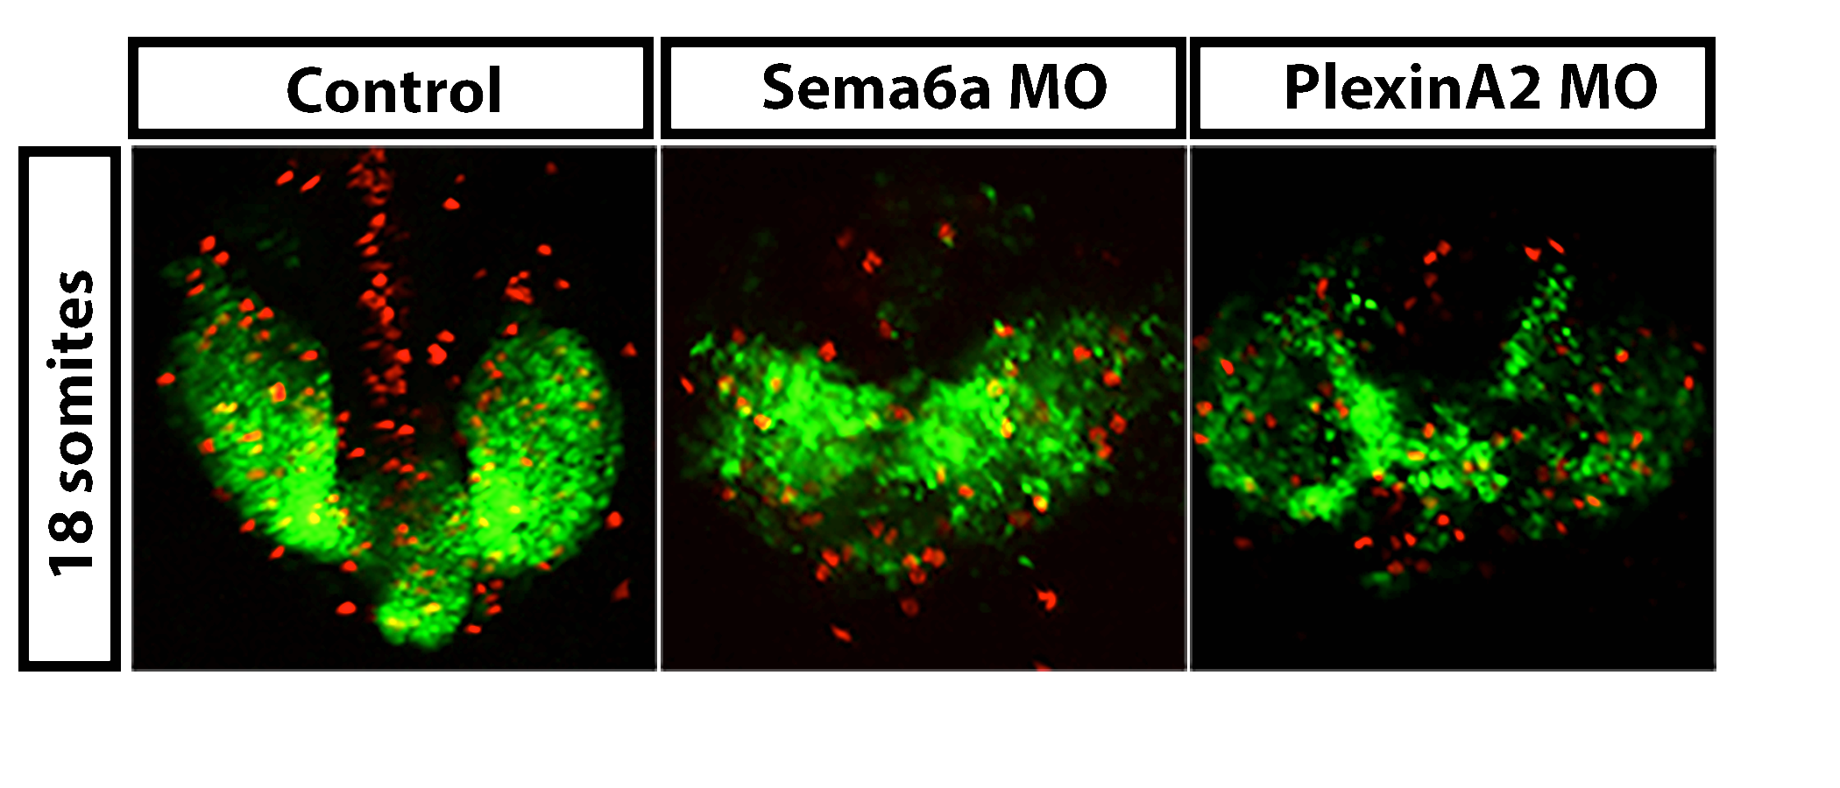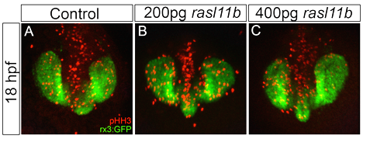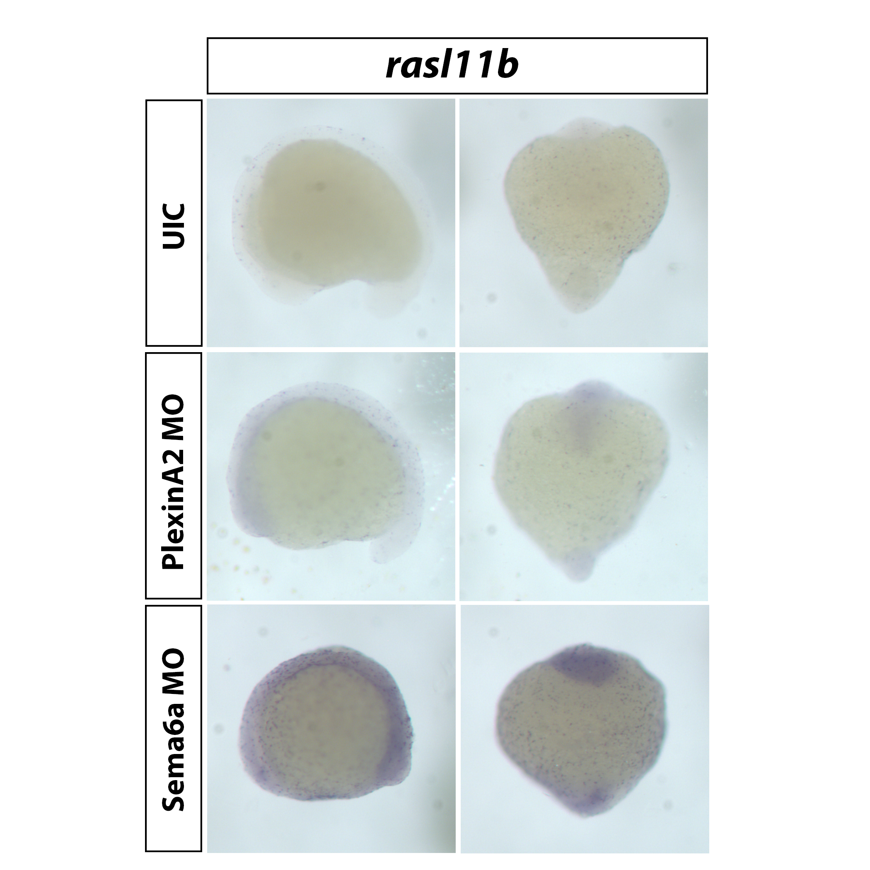**1b) Preliminary data** Morpholino antisense oligonucleotides (MO) targeted to either *plxnA2* or *Sema6A* results in decreased proliferation and a loss of cohesion within migrating optic vesicles (Fig. 1). To understand the downstream events driving these phenotypes, we again used MO to knockdown PlxnA2 and Sema6A and compared gene expression levels to un-injected control embryos. Using a Nimblegen zebrafish microarray chip, we found 58 genes that were differently regulated in common to both MO treatments. The 58 genes of interest were grouped by known/putative function based on published data. *In situ* hybridization validated expression changes in a set of genes as shown in microarray results. Preliminary data shows that overexpression of one gene that was significantly up regulated in morphants, *rasl11b,* leads to significantly decreased proliferation of RPCs (Fig 2).

**Figure 1. *Sema6A* and *plxnA2* knockdown leads to loss of cohesion and decreased proliferation in eye vesicles**. A. Confocal dorsal views of 18 somite rx3:GFP embryos co-labeled with pHH3. Both *Sema6A* and *plxnA2* morphants display ectopic retinal precursor cells outside the eye field as well as significantly reduced pHH3 positive cells in the developing eyes as compared to controls.Error bars indicate SEM. (**** P<0.0001; one-way ANOVA.). n=30

**Figure 2. Overexpression of *rasl11b* decreases proliferation of RPCs. A.** *Rasl11b* expression increases in morphant embryos at 18 somites. **B.** Confocal dorsal views of 18 somite rx3:GFP embryos co-labeled with pHH3. Increasing levels of rasl111b leads to significant decreases in proliferation. n=30.

**** ****

**1c) Design and methods.** *In situ* hybridization will be used to validate changes in expression of further genes of interest from microarray results. DIG labeled single stranded antisense riboprobes will be generated following PCR amplification and sequencing of a 500bp region of the gene of interest. Probes will be used on fixed 18 somite WT, Sema6a or PlxnA2 morphant embryos, and sense probes will be generated as controls for non-specific staining. Overexpression experiments will be used to identify phenotypes that arise form increases in expression. Full length, capped mRNA will be injected into one cell stage rx3:GFP embryos which will be fixed at 18 somites. Initial dose responses will be performed to balance lethality with observable phenotypes. Embryos will be processed depending on the role of the gene of interest for either immunohistochemistry using pHH3 antibodies as an indicator of proliferating cells, or general eye morphology will be observed and eye size counts will be performed to asses any migratory phenotypes of developing eye fields using confocal fluorescence microscopy and SPOT imaging software. Experiments will have n=30, N=3. Un-injected rx3:GFP embryos will be processed in parallel to serve as controls. To begin to identify the roles and protein interactions of overexpressed genes, HEK293 cells will be used, transfected with DNA of the gene of interest, followed by western blotting to look for changes in levels of predicted interacting proteins. For example, cells transfected with additional genes that may have roles in proliferation will be blotted to look for changes in levels of proteins involved in the MAPK cascade. Western blots will be processed in Adobe Photoshop for densitometry analysis, and at least 3 separate experiments will be analyzed for statistical significance using PRISM software. The roles of genes will be confirmed in rescue experiments in which full length mRNA will be co-injected with Sema6a/PlxnA2 MOs and expected to at least partially rescue morphant embryos if they are downstream of this signaling pathway. The use of zebrafish in proposed experiments is approved by the University of Vermont Institutional Animal Care and Use Committee (IACUC).

**1d) Feasibility problems & approaches.** The main body of work for aim 1 has been successfully attempted for initial validation of select genes and characterization of *rasl11b*. Further work will revisit techniques already mastered, with different genes of focus.If *in situ* hybridization experiments or probe generation is unsuccessful, RT-qPCR could be implemented as an alternative method to measure changes in gene expression.

**1e) Goals and expected outcomes.** The body of work completed so far has been compiled into a transcript for submission to the journal Developmental Dynamics, Patterns and Phenotypes. Future goals include characterization of additional downstream genes in the group of 58 genes of interest, focusing on genes involved in migration, for example the microtubule associated protein, *dcdc2b*. As dcdc2b was shown to be significantly up regulated in morphants, it is hypothesized that overexpression would lead to migration defects in optic vesicles, and lack of cohesion would be observed resulting in ectopic cells.

**Aim 2 – Delineate the downstream transcriptional effectors of Sema6A/PlxnA2 signaling in retinal precursor cells during early eye development.**

**2a) Introduction** The requirements for Sema6A/PlxnA2 signaling in development are well characterized and these receptors have been shown to play critical roles in maintaining cohesion within developing optic vesicles (Ebert et al., 2014), neuronal positioning in the cerebellum (Renaud and Chetodal 2014, Renaud et al., 2008), lamination of the hippocampus (Tawarayama et al., 2010), and guidance of the corticospinal tract (Runker at al., 2008). We will test the **hypothesis that Sema6A/PlxnA2 signaling controls RPC developmental gene expression programs via activation of specific transcriptional effectors.** Our preliminary microarray analysis of WT, Sema6A morphant and PlxnA2 morphant embryos, indicates that these receptors share overlapping transcriptional responses (Fig. 3). However, further investigation is required to elucidate the transcriptional responses downstream of Sema6A/PlxnA2 in retinal precursor cells (RPCs) and to identify the transcriptional effectors that mediate these critical responses. Thus, **the overall goal** of this aim is to delineate the downstream transcriptional effectors of Sema6A/PlxnA2 signaling in RPCs. We will generate targeted Sema6A and PlxnA2 mutants, isolate RPCs from these animals and perform RNA-sequencing analysis determine the impact of Sema6A/PlxnA2 loss of function on global gene expression (**Aim2A**). To identify potential transcriptional effectors of Sema6A/PlxnA2 signaling, we will use chromatin accessibility analysis by ATAC-seq and chromatin structure analysis by histone modification ChIP-seq to define genomic response elements and transcriptional mechanisms that mediate Sema6A/PlxnA2 developmental signaling (**Aim2B**).

**2b) Preliminary data.** Microarray results show that 57/58 genes that are differentially regulated in PlexinA2 and Sema6A morphant embryos are significantly up regulated compared to controls (Fig 3).PlxnA2 mutants are currently in the F1 generation and are being validated via sequencing. Rx3:GFP embryos injected with PlxnA2 targeted gRNA and global Cas9 phenocopied PlxnA2 morphant embryos, with smaller eyes and cardiac edemas. CRISPR/Cas9 nanos (germ line specific) injected embryos were grown up and outcrossed to an rx3:GFP transgenic line and are being sequenced to look for hets. Validated hets will be outcrossed to generate a stable line with one mutation. Sema6A CRISPR/Global Cas9 phenocopy morphants at F0, and are being injected with Cas9nanos.

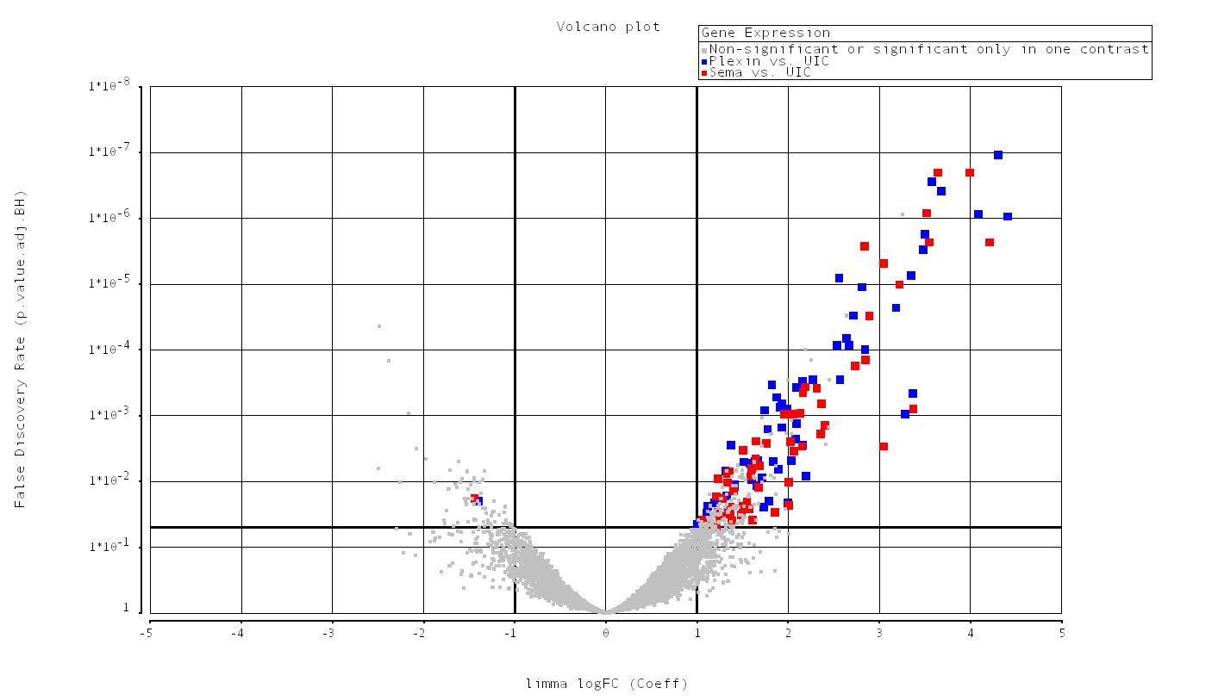

***Figure 3. Significant gene expression changes in Sema6A and PlxA2 morphants****.* Volcano plot of 58 genes significantly differentially regulated in common to Sema6a (red) and PlxnA2 (blue) morphants. 57/58 genes in common to both Sema6a and PlxnA2 morphants increased in expression.

False discovery rate (p-value adj. BH)

Log Fold change

**2c) Design and Methods** Preliminarymicroarray analysis was performed using RNA extracted from whole embryos, so results may not be eye specific. Aim 2 will use eye specific RPCs isolated from PlxnA2 mutant, Sema6A mutant and WT embryos at 18 somites. CRISPR mutants will be generated on an *rx3*:GFP transgenic background. Embryos will be fixed, dissociated and FAC sorted for GFP positive cells. Generating mutants will ensure higher confidence and uniformity in results compared to morphants. RPCs from each mutant and WT control will be isolated and their nuclei will be extracted for RNA isolation (100ng-1μg/condition). Prior to use for Illumina RNA-seq, rRNA will be depleted. RNA-seq will determine the RPC transcriptome at 18 somites in order to analyze differences in gene expression between mutants and WT. 10,000 Isolated RPCs from mutant and WT embryos will be used for ATAC-seq (assay for transposase accessible chromatin followed by high throughput sequencing). This technique will analyze differences in open chromatin footprints between WT and mutant RPCs where chromatin accessibility will be used as a proxy for active sites of transcription. ATAC-seq uses modified hyperactive transposases, which allow for the efficient cutting of exposed regions of DNA. Adapter sequences are ligated to the isolated fragments to enable for high throughput sequencing. Bioinformatics will be used to mine sequences that show differences in chromatin accessibility between mutant and WT RPCs for regulatory elements. ChIP-seq (Chromatin immunopreciptiation followed by high throughput sequencing) will be utilized as a secondary technique to look for areas of transcriptional repression and activation/enhancer regions. Antibodies against two histone modification markers, H3K27me3 (tri methylation of lysine on histone 27) as a marker of areas of repression (Young et al., 2011) and H3K27ac (tri acetylation of lysine on histone 27) as a marker of active/enhancer regions will be used. WT and mutant generated footprints will be compared to identify possible transcriptional control elements of target genes downstream of Sema6A/PlxnA2 signaling. This aim will establish differences in chromatin accessibility and histone modifications in mutant compared to WT RPCs, therefore it will be possible to look for enhancers, repressors or transcription factor binding motifs to begin to understand the regulatory elements downstream of Sema6A/PlxnA2 signaling.

**2d) Feasibility problems & approaches** CRISPR/Cas9 mutagenesis has been successful in zebrafish and is currently underway in our lab.If CRISPR mutagenesis is unsuccessful, alternative target guide RNAs will be designed and multiple targets will be injected at once. Mutants are also becoming available from vendors**.** Alternatively, already validated morphant embryos would be used. Genomic experiments will be performed in collaboration with Dr. Seth Frietze in the Medial Laboratory Science Department at UVM. ATAC and ChIP-seq have been shown to work with 10,000 cells, and RNA-seq with as little as 100ng RNA. Given that zebrafish have numerous offspring, isolating sufficient numbers of cells will be possible.

**2e) Goals and expected outcomes** Sema6A and PlxnA2 *rx3*:GFP CRISPR mutant zebrafish will be generated and maintained as stable lines. FAC sorting of embryos will be optimized to isolate required numbers of RPCs (10,000 for each ATAC-seq and ChIP-seq assay). RNA-seq will determine the RPC transcriptome and uncover differences in gene expression between WT and mutant cells. It is hypothesized that Sema6A/PlxnA2 mutants will have differences in chromatin accessibility and transcription factor regulation of gene expression compared to WT. In looking for differences in chromatin structure and histone modifications, we will at first identify areas of differences, and then sequence the areas for further bioinformatics analysis. This will enable us to look for regulatory elements, transcription factor binding sites, and begin to elucidate the transcriptional regulatory mechanisms downstream of Sema6A/PlxnA2 signaling

**Aim 3–** Characterizing expression and function of additional Plexin A family of receptors in early zebrafish eye development.

**3a) Introduction** Semas can bind to multiple different Plxn receptors and typically a Sema will bind to multiple members of the same class. There are 4 PlxnA family members, A1-4, which bind to members of class 3 and class 6 Semas. Ligand-receptor interactions are dependent on tissue specific and temporal expression patterns of each protein. Intercellular differences in expression also can alter signaling, dependent on whether receptors and ligands are present on the same (*cis*) or different (*trans*) cell membranes. (Haklai-Topper et al., 2010). Sema6a is known to bind to PlxnA2 and A4 (Nogi et al., 2010). This group of signaling molecules has been found to pattern the hippocampus, in which PlxnA2 acts to attenuate Sema6a repulsion via PlxnA4, which controls lamination of mossy fiber projections (Suto et al., 2007). It has been shown that Sema6a is expressed at the same early stages as PlxnA2 in the developing zebrafish eye and when either is knocked down, the same phenotypes arise of decreased proliferation and cohesion of RPCs (Ebert et al., 2014). Preliminary work shows that PlxnA1 has a potential compensatory role for PlxnA2 in optic vesicles. However, it is unknown if PlxnA4 or PlxnA3 are expressed in or around optic vesicles at this same early stage and could be playing a role in development. We will test the **hypothesis that PlxnA1, A2 and A4 are expressed in the early eye and specific expression domains of the receptors are important in the regulation of Sema6a signaling in early eye development.** The **overall goal** of this aim will be to use MO knockdown and CRISPR mutagenesis of PlxnAs in combination with *in situ* hybridization to comprehensively uncover the expression patterns of the PlxnA family in the early developing eye and address roles in early eye development.

**3b) Preliminary data** *In situ* data shows that PlxnA2 is expressed in the ventral eye and surrounding head mesenchyme, as early as 4 somites and PlxnA1 is expressed in overlapping regions (Fig 4a). PlxnA1 morphant embryos phenocopy PlxnA2 morphants, showing decreased proliferation and cohesion within developing eye fields at 18 somites (Fig 4b). There may be a compensatory role for PlxnA1 and A2 in the developing eye, as expression of reciprocal Plxns increases when the other is knocked down. Current models suggest that in the developing optic vesicle, Sema6A is expressed throughout and ventral expression of PlxnA2 neutralizes repulsion of Sema6a expressing RPCs allowing them to enter the vesicle in the ventral domain. It is unknown what controls the organization of RPCs in the dorsal optic vesicle.

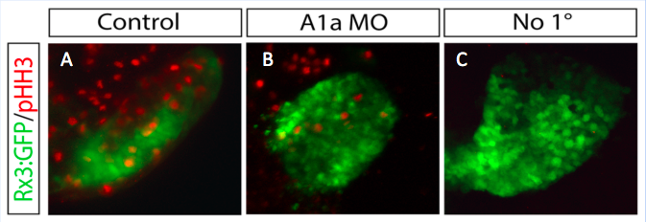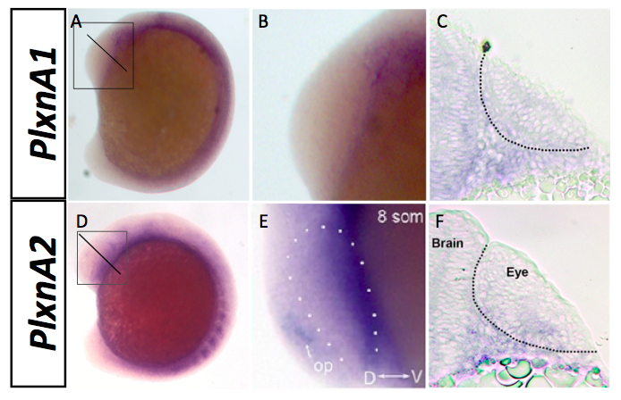

***Figure 4 Potential compensation for PlxnA1 and A2. A.*** PlxnA1&A2 overlapping expression in developing eye fields at 4-8 somites, whole mount (A,D), zoom (B,E) and transverse sections (C,F)**. B.** PlxnA1 MO phenocopies PlxnA2 morphant phenotypes of decreased proliferation and cohesion.

A

B

**3c) Design and methods** Single stranded DIG labeled antisense riboprobesfor PlxnA3 and A4 will be generated from 500bp gene specific regions amplified using PCR. Probes will be used to look for mRNA expression in the developing eye on fixed wild type embryos at stages between 4 somites-24hpf. Expression will be initially validated in whole mount using bright field microscopy, and further analyzed after embedding and sectioning. Morpholinos will be designed to screen for phenotypes, if expression is confirmed in the eye and will be injected with and without co-injection of p53 MO to control for off target cell death. CRISPR mutants will be generated for PlxnA1 and any additional PlxnAs that show significant morphant phenotypes in the developing eye to facilitate more reliable analyses. Mutants will be used for rescue experiments. For example, PlxnA1 mutants will be injected with full length PlxnA2 mRNA to see if there is compensation of function. Other Plxn receptors will be analyzed in the same way. Mutant stable lines will allow for in crossing of different PlxnA mutants to see if phenotypes are compounding. *In situs* of domain specific markers of optic vesicles will be used to address any early organizational defects in Plxn mutants to elucidate possible roles. For example at 12 somites, Fox-x1a and tbx-5 are expressed in the dorsal vesicle, whereas vax-2 is expressed ventrally (Ebert et al., 2014). Changes in expression domains of these markers in mutants will uncover potential roles for plxns in the organization RPCs within the optic vesicles.

**3d) Feasibility problems & approaches** All proposed techniques are routinely successfully performed in our lab. If PCR amplification is unsuccessful for probe generation, a 500bp gene specific construct could be ordered, or RT-qPCR could be used. Trouble shooting of CRISPR mutagenesis will be as in aim 2.

**3e) Goals and expected outcomes** This aim willgenerate a comprehensive expression profile of the PlxnA family of receptors throughout early eye development in zebrafish.MO screening will elucidate phenotypes of any that show eye expression prior to mutant generation. Mutant stable lines will be generated of any that show promising phenotypes using CRISPR that can be used for future experiments.Mutants will be used to elucidate the roles of PlxnA family members during early eye development, and if there is redundancy and compensation between receptors. This will uncover the dynamic interactions between the different members of the PlxnA family, which we hypothesize to be controlling early eye development.

**Time line**

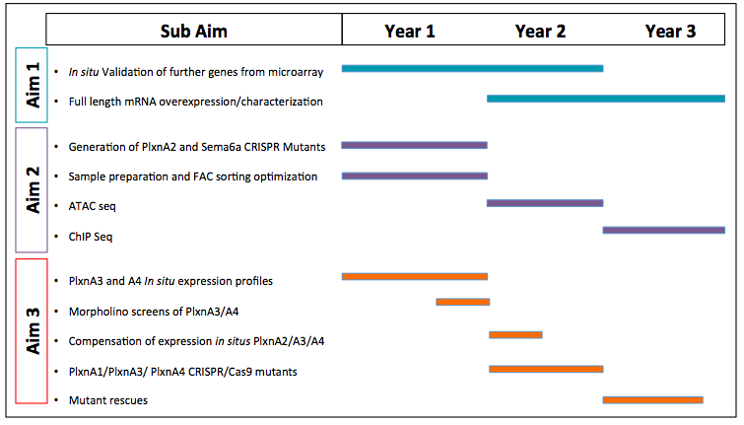

***Abbreviations***

ATAC seq, Assay for transposase accessible chromatin followed by high throughput sequencing

ChIP seq, Chromatin immunopreciptiation followed by high throughput sequencing

CRMP, collapsin response mediator protein

EFTFs, eye field transcription factors

FACS, Fluorescent activated cell sorter

GAP, GTPase-activating protein

GDNF, Glial cell derived neurotropic factor

GEF, Guanine nucleotide exchange factor

Hpf, Hours post fertilization

MO, Morpholino

Plxn, Plexin

RPCs Retinal precursor cells

RX3, retinal homeobox gene 3

Sema, Semaphorin

VEGF, vascular endothelial growth factor

VEGFR, vascular endothelial growth factor receptor

**References**

Adler, R., Canto-Soler, M.V., 2007. Molecular mechanisms of optic vesicle development: complexities, ambiguities and controversies. Dev Biol 305, 1-13.

Behar, O., Golden, J.A., Mashimo, H., Schoen, F.J., Fishman, M.C., 1996. Semaphorin III is needed for normal patterning and growth of nerves, bones and heart. Nature 383, 525-528.

Bos, J.L., Rehmann, H., Wittinghofer, A., 2007. GEFs and GAPs: Critical Elements in the Control of Small G Proteins. Cell 129, 865-877.

Buel, G.R., Rush, J., Ballif, B.A., 2010. Fyn promotes phosphorylation of collapsin response mediator protein 1 at tyrosine 504, a novel, isoform-specific regulatory site. Journal of Cellular Biochemistry 111, 20-28.

Ebert, A.M., Childs, S.J., Hehr, C.L., Cechmanek, P.B., McFarlane, S., 2014. Sema6a and Plxna2 mediate spatially regulated repulsion within the developing eye to promote eye vesicle cohesion. Development 141, 2473-2482.

Gherardi, E., Love, C.A., Esnouf, R.M., Jones, E.Y., 2004. The sema domain. Current Opinion in Structural Biology 14, 669-678.

Giordano, S., Corso, S., Conrotto, P., Artigiani, S., Gilestro, G., Barberis, D., Tamagnone, L., Comoglio, P.M., 2002. The semaphorin 4D receptor controls invasive growth by coupling with Met. Nat Cell Biol 4, 720-724.

Haklai-Topper, L., Mlechkovich, G., Savariego, D., Gokhman, I., Yaron, A., 2010. Cis interaction between Semaphorin6A and Plexin-A4 modulates the repulsive response to Sema6A. The EMBO Journal 29, 2635-2645.

Halder, G., Callaerts, P., Gehring, W.J., 1995. Induction of ectopic eyes by targeted expression of the eyeless gene in Drosophila. Science (New York, N.Y.) 267, 1788-1792.

Kolodkin, A.L., Matthes, D.J., O'Connor, T.P., Patel, N.H., Admon, A., Bentley, D., Goodman, C.S., 1992. Fasciclin IV: sequence, expression, and function during growth cone guidance in the grasshopper embryo. Neuron 9, 831-845.

Luo, Y., Raible, D., Raper, J.A., 1993. Collapsin: A protein in brain that induces the collapse and paralysis of neuronal growth cones. Cell 75, 217-227.

Macdonald, R., Barth, K.A., Xu, Q., Holder, N., Mikkola, I., Wilson, S.W., 1995. Midline signalling is required for Pax gene regulation and patterning of the eyes. Development 121, 3267-3278.

Negishi, M., Oinuma, I., Katoh, H., 2005. Plexins: axon guidance and signal transduction. Cellular and molecular life sciences : CMLS 62, 1363-1371.

Neufeld, G., Kessler, O., 2008. The semaphorins: versatile regulators of tumour progression and tumour angiogenesis. Nature reviews. Cancer 8, 632-645.

Nogi, T., Yasui, N., Mihara, E., Matsunaga, Y., Noda, M., Yamashita, N., Toyofuku, T., Uchiyama, S., Goshima, Y., Kumanogoh, A., Takagi, J., 2010. Structural basis for semaphorin signalling through the plexin receptor. Nature 467, 1123-1127.

Pasterkamp, R.J., 2005. R-Ras fills another GAP in semaphorin signalling. Trends in Cell Biology 15, 61-64.

Perala, N., Jakobson, M., Ola, R., Fazzari, P., Penachioni, J.Y., Nymark, M., Tanninen, T., Immonen, T., Tamagnone, L., Sariola, H., 2011. Sema4C-Plexin B2 signalling modulates ureteric branching in developing kidney. Differentiation 81, 81-91.

Perälä, N., Sariola, H., Immonen, T., 2012. More than nervous: the emerging roles of plexins. Differentiation 83, 77-91.

Roessler, E., Belloni, E., Gaudenz, K., Jay, P., Berta, P., Scherer, S.W., Tsui, L.C., Muenke, M., 1996. Mutations in the human Sonic Hedgehog gene cause holoprosencephaly. Nat Genet 14, 357-360.

Rosslenbroich, V., Dai, L., Baader, S.L., Noegel, A.A., Gieselmann, V., Kappler, J., 2005. Collapsin response mediator protein-4 regulates F-actin bundling. Experimental Cell Research 310, 434-444.

Schmidt, E.F., Strittmatter, S.M., 2007. The CRMP Family of Proteins and Their Role in Sema3A Signaling, in: Pasterkamp, R.J. (Ed.), Semaphorins: Receptor and Intracellular Signaling Mechanisms. Springer New York, New York, NY, pp. 1-11.

Segarra, M., Ohnuki, H., Maric, D., Salvucci, O., Hou, X., Kumar, A., Li, X., Tosato, G., 2012. Semaphorin 6A regulates angiogenesis by modulating VEGF signaling. Blood 120, 4104-4115.

Serini, G., Valdembri, D., Zanivan, S., Morterra, G., Burkhardt, C., Caccavari, F., Zammataro, L., Primo, L., Tamagnone, L., Logan, M., Tessier-Lavigne, M., Taniguchi, M., Puschel, A.W., Bussolino, F., 2003. Class 3 semaphorins control vascular morphogenesis by inhibiting integrin function. Nature 424, 391-397.

Shi, W., Kumanogoh, A., Watanabe, C., Uchida, J., Wang, X., Yasui, T., Yukawa, K., Ikawa, M., Okabe, M., Parnes, J.R., Yoshida, K., Kikutani, H., 2000. The Class IV Semaphorin CD100 Plays Nonredundant Roles in the Immune System: Defective B and T Cell Activation in CD100-Deficient Mice. Immunity 13, 633-642.

Suto, F., Tsuboi, M., Kamiya, H., Mizuno, H., Kiyama, Y., Komai, S., Shimizu, M., Sanbo, M., Yagi, T., Hiromi, Y., Chedotal, A., Mitchell, K.J., Manabe, T., Fujisawa, H., 2007. Interactions between plexin-A2, plexin-A4, and semaphorin 6A control lamina-restricted projection of hippocampal mossy fibers. Neuron 53, 535-547.

Toyofuku, T., Zhang, H., Kumanogoh, A., Takegahara, N., Suto, F., Kamei, J., Aoki, K., Yabuki, M., Hori, M., Fujisawa, H., Kikutani, H., 2004. Dual roles of Sema6D in cardiac morphogenesis through region-specific association of its receptor, Plexin-A1, with off-track and vascular endothelial growth factor receptor type 2. Genes Dev 18, 435-447.

Vergara, M.N., Canto-Soler, M.V., 2012. Rediscovering the chick embryo as a model to study retinal development. Neural Development 7, 1-19.

Yang, T., Terman, J.R., 2013. Regulating small G protein signaling to coordinate axon adhesion and repulsion. Small GTPases 4, 34-41.

Young, M.D., Willson, T.A., Wakefield, M.J., Trounson, E., Hilton, D.J., Blewitt, M.E., Oshlack, A., Majewski, I.J., 2011. ChIP-seq analysis reveals distinct H3K27me3 profiles that correlate with transcriptional activity. Nucleic Acids Research.

Yu, L., Zhou, Y., Cheng, S., Rao, Y., 2010. Plexin a-semaphorin-1a reverse signaling regulates photoreceptor axon guidance in Drosophila. The Journal of neuroscience : the official journal of the Society for Neuroscience 30, 12151-12156.

Zuber, M.E., Gestri, G., Viczian, A.S., Barsacchi, G., Harris, W.A., 2003. Specification of the vertebrate eye by a network of eye field transcription factors. Development 130, 5155-5167.